WHATNEXT VISION MOTORS
Shaping the Future of Mobility with Innovation and Excellence
Phase 1: Requirement Analysis & Planning
Organization : WhatNext Vision Motors
Platform : Salesforce CRM / Web Application

PROJECT TEAM DETAILS
S.NO | NAME | ROLE | PHASE  RESPONSIBILITY
1. | Antony Aruldas | Team Lead / Developer | Requirement Analysis & Planning
2. | Shanu | Team Lead / Developer | Design, Development & Testing
3. | Lokesh | UI/UX Designer | Interface Design & User Experience
4. | Sunil Kumar | Tester / Analyst | Testing, Debugging & Documentation

TABLE OF CONTENTS
- Project Introduction
- Business Objectives
- Functional Scope
- Stakeholder Mapping
- Execution Roadmap
- Assumptions
- Risks
- Future Enhancements
- Conclusion

1. PROJECT INTRODUCTION
WhatNext Vision Motors CRM is a modern vehicle management system designed to transform traditional automotive operations into a smart, automated, and customer-centric platform.
The system helps:
- Manage vehicle inventory
- Automate customer orders
- Assign dealers based on location
- Track vehicle delivery
- Improve customer engagement
This platform enhances efficiency, reduces manual work, and supports intelligent decision-making.

2. BUSINESS OBJECTIVES
2.1 Enhance Operational Efficiency
Automate vehicle ordering, dealer allocation, and inventory management to reduce manual errors and improve workflow speed.

2.2 Improve Customer Experience
Provide seamless vehicle browsing, booking, and real-time order tracking to enhance satisfaction.

2.3 Optimize Dealer Management
Assign the nearest available dealer automatically based on customer location.

2.4 Strengthen Sales & Revenue Tracking
Ensure accurate billing, order confirmation, and revenue tracking through automation.

2.5 Enable Data-Driven Decisions
Provide reports and dashboards for analyzing:
- Sales trends
- Customer preferences
- Dealer performance

3. FUNCTIONAL SCOPE
3.1 Application Overview
A Salesforce-based or Web-based CRM application named:
👉 “WhatNext Vision Motors System”

3.2 Data Model
Custom Objects:
- Customer
- Vehicle
- Dealer
- Order
Relationships:
- Customer → Order
- Dealer → Order
- Vehicle → Order

3.3 User Interface
- Simple and user-friendly dashboards
- Separate interfaces for admin and users
- Easy navigation system

3.4 Automation Features
Formula Fields
- Total Price Calculation
- Vehicle Availability Status

Validation Rules
- Prevent ordering unavailable vehicles
- Validate customer details

Flows
- Send order confirmation emails
- Notify delivery updates

Apex Triggers
- Auto-assign nearest dealer
- Update inventory after order

Scheduled Automation
- Send reminders for delivery
- Notify customers about offers

3.5 Analytics
- Sales Reports
- Dealer Performance Reports
- Customer Insights
Dashboards provide visual representation for better decision-making.

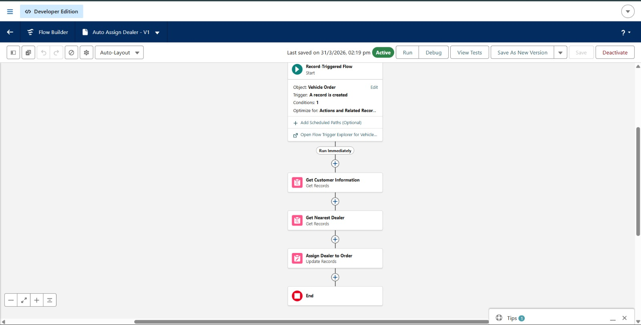

4. STAKEHOLDER MAPPING
4.1 Customers
Users who browse and purchase vehicles.

4.2 Dealers
Responsible for fulfilling vehicle orders.

4.3 Admin Staff
Manage system data and operations.

4.4 Managers
Monitor reports and make business decisions.

4.5 System Administrator
Maintains system configuration and security.

5. EXECUTION ROADMAP
5.1 Environment Setup
- Create Salesforce Developer Account

5.2 Backend Data Modeling
- Create objects and relationships

5.3 Application Setup
- Build Lightning App
- Create tabs

5.4 Backend Logic Implementation
- Formula fields
- Validation rules
- Flows
- Apex triggers

5.5 UI Customization
- Design page layouts
- Improve user experience

5.6 Data Population & Testing
- Insert sample data
- Perform testing

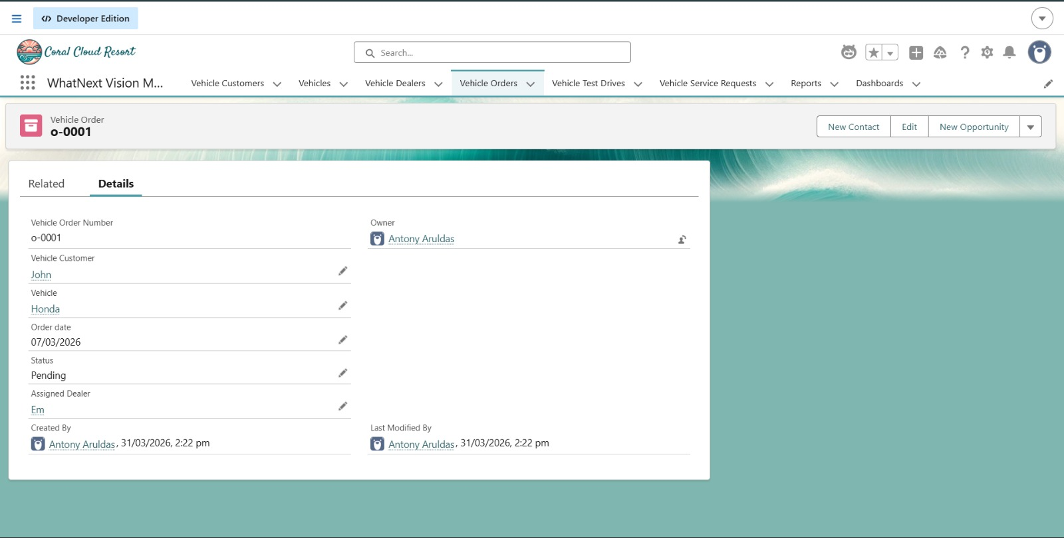

5.7 Analytics Setup
- Create reports
- Design dashboards

5.8 Final Review
- Demo preparation
- Documentation completion

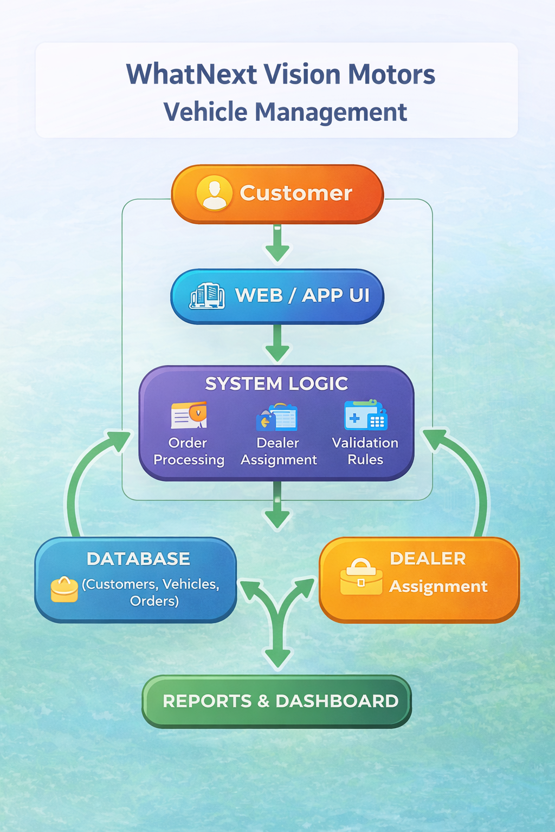

6. ASSUMPTIONS
- Users have internet access
- Vehicles are updated in real-time
- Dealers are available for delivery
- Payments are processed digitally

7. RISKS
- System downtime
- Incorrect dealer assignment
- Data inconsistency
- Delay in notifications

8. FUTURE ENHANCEMENTS
- AI-based vehicle recommendation system
- Mobile application development
- IoT-based vehicle tracking
- Voice assistant integration
- Electric vehicle analytics

9. CONCLUSION
The WhatNext Vision Motors system provides a smart and scalable solution for modern automotive business operations. By automating workflows, improving customer interaction, and enabling real-time insights, the system ensures higher efficiency, accuracy, and customer satisfaction.

